JMeter

Prerequisites
- MobaXterm
- VPN / Workspace
- Pem file (iexceed-pt.pem)
JMeter EC2 machine IP address and username
IP Address
- 172.16.101.143
- 172.16.101.13
Username
ec2-user
To Open JMeter in GUI mode
- Open Mobaxterm
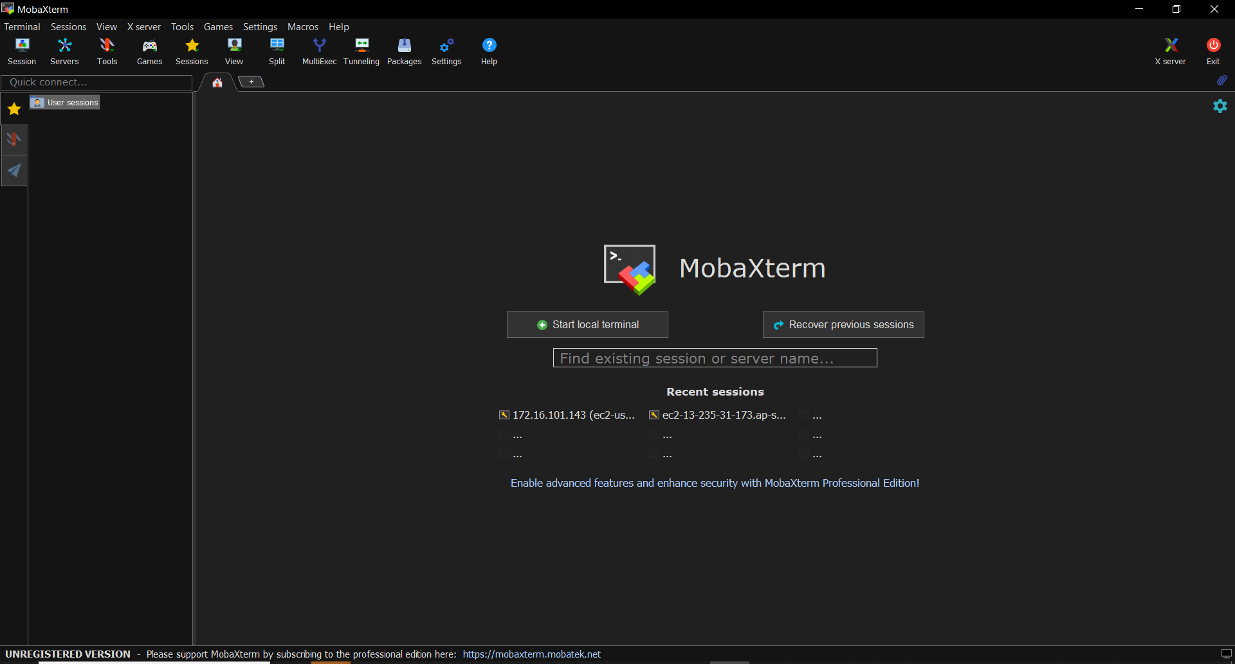
  - Home Screen

- After opening Mobaxterm we need to start a new session if you are setting up for the first time.
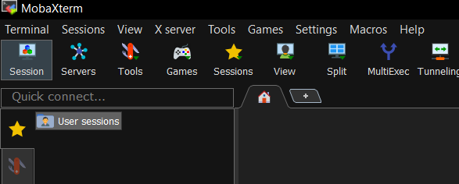
Select Session on the top left corner.

- Now we need to select the SSH option.
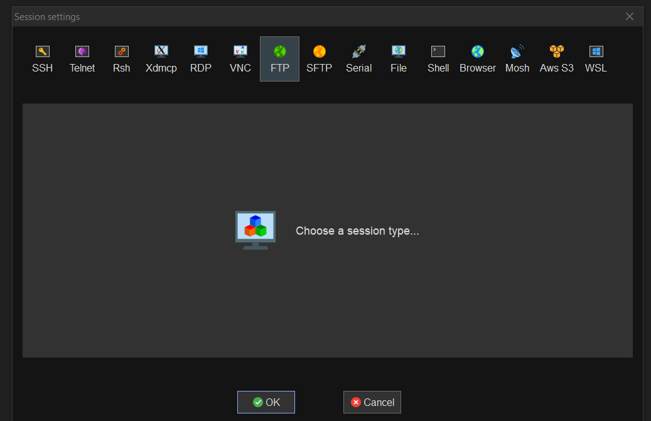
Click on SSH adn

- After selecting SSH a new screen will appear we need to enter the JMeter EC2 instance IP address the username.

Enter the Ip address here.
Select Specify username and Enter the Username here.

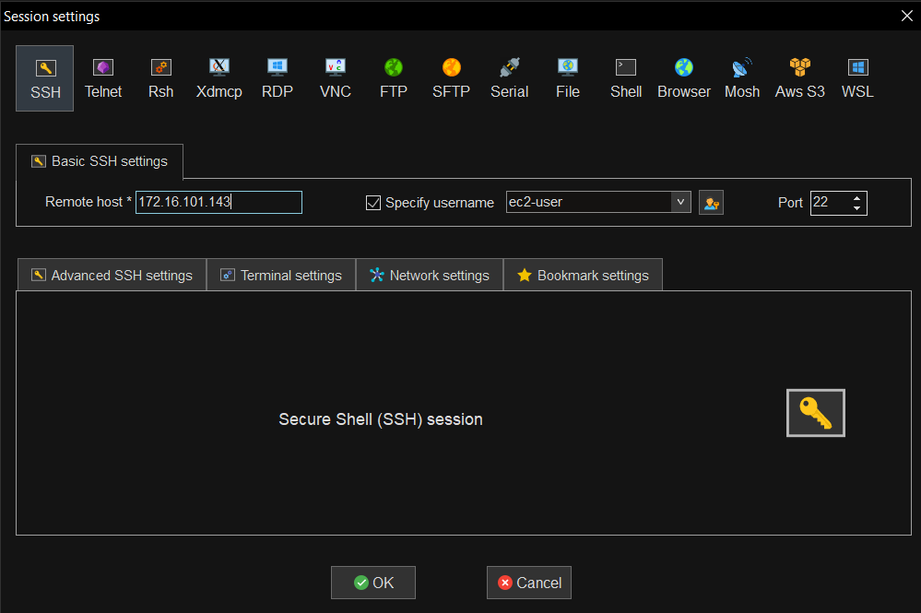

After entering the Ip address and Username click on Advanced SSH Settings.

- Under Advanced Settings ensure that X11 forwarding option is enabled and upload the pem key file by selecting use private key.
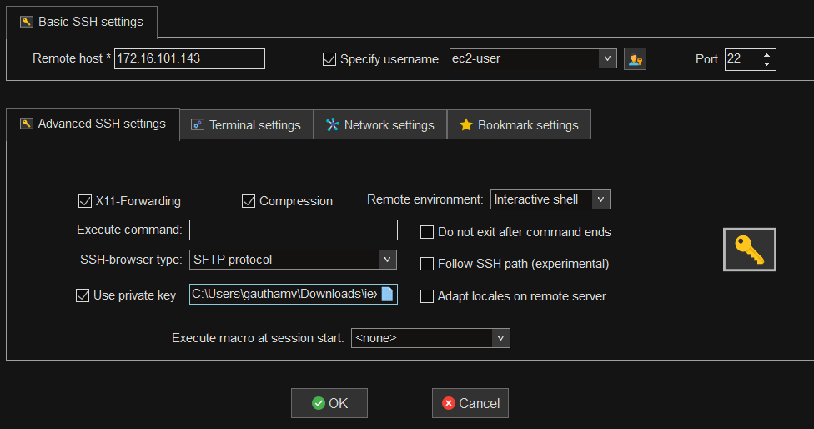
Click on Use private key and upload the iexceed-pt.pem file.
Ensure X11 forwarding is enabled.
- Click on Enter and the following screen will be loaded.
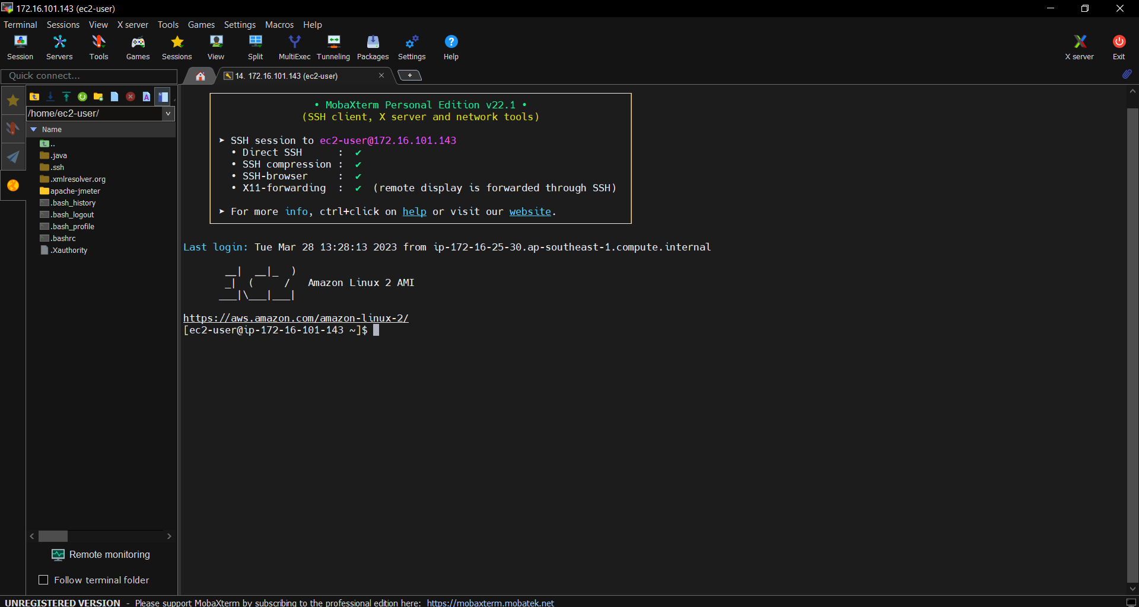
Enter the following commands one after the other: -
- cd apache-jmeter/apache-jmeter-5.5/bin/
- ./jmeter (to start the JMeter in GUI mode)
After entering the 2nd command, the following screen will appear and JMeter will open in GUI mode
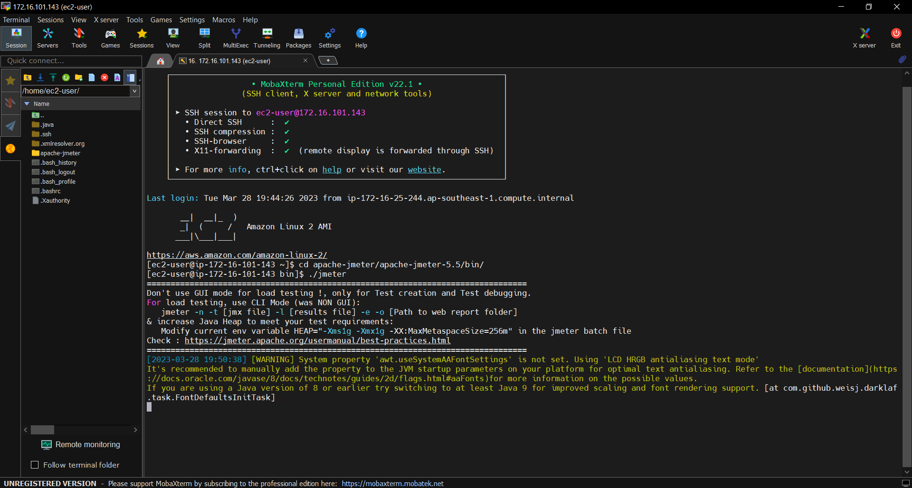
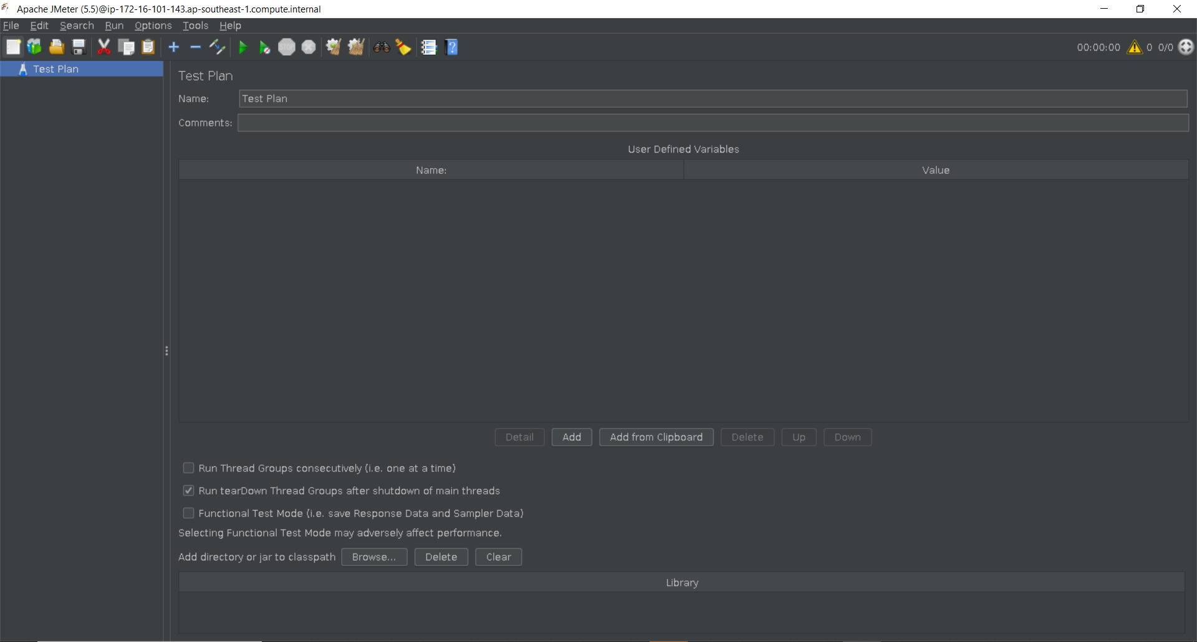
JMeter GUI

The process of launching the JMeter from the second time onwards is simple.
- Open MobaXterm the following screen will appear. The previous session will be saved. We can double click on the saved session and enter the EC2 machine.
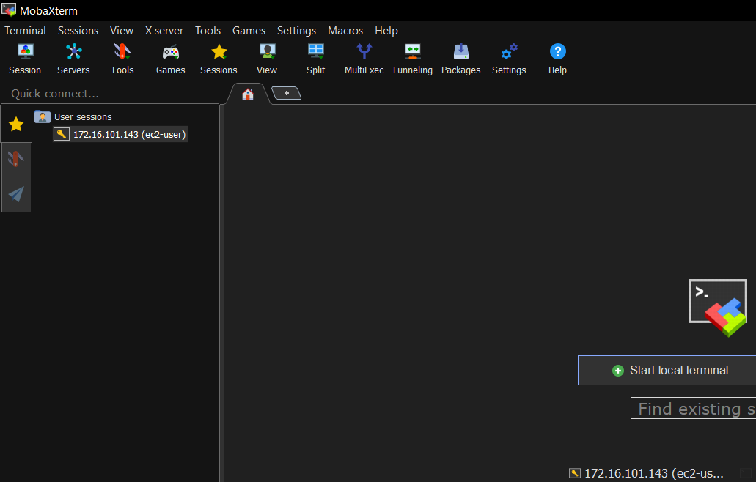
Saved sessions will appear here. Double click on the Ip address
- After logging into the EC2 machine enter the same commands used previously
  - cd apache-jmeter/apache-jmeter-5.5/bin/
  - ./jmeter

